## Advanced snapping

For additional snapping options, press the Alt key while snapping to a geometry to enable guides for tangent and perpendicular lines as well as geometry midpoints.

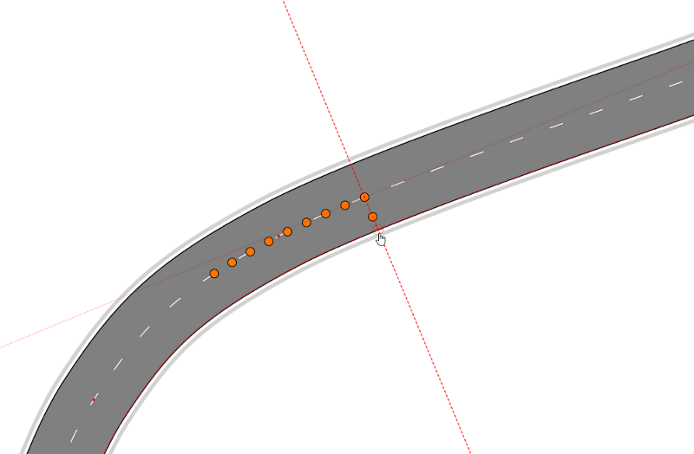

Advanced_snapping